1. INTRODUCTION :-

Facial recognition is the process of identifying or verifying the identity of a person using their face. It captures, analyzes, and compares patterns based on the person's facial details. High-Quality Facial Recognition System has many applications starting from mobile phones to security cameras. The face detection process is an essential step as it detects and locates human faces in images and videos.

Artificial Intelligence (AI) is that wave sweeping the technology world today.

In addition to the development of machine learning that leads to new capabilities, we

have subsets within the domain of machine learning, each of which offers a potential

area of specialization for those interested in a career in AI.

● Neural Networks

Neural networks are integral for teaching computers to think and learn by

classifying information, similar to how we as humans learn. With neural networks,

the software can learn to recognize images, for example. Machines can also

make predictions and decisions with a high level of accuracy based on data

inputs.

● Natural Language Processing (NLP)

Natural language processing gives machines the ability to understand human

language. As this develops, machines will learn to respond in a way a human

audience can understand. In the future, this will dramatically change how we

interface with all computers.

● Deep Learning

Deep learning is at the cutting-edge of intelligent automation. It focuses on

machine learning tools and deploying them to solve problems by making

decisions. With deep learning, data is processed through neural networks,

getting closer to how we think as humans. Deep learning can be applied to

images, text, and speech to draw conclusions that mimic human decision

making.

We'll be exploring how to use Python and the OpenCV (Open Computer Vision) library

to analyze images and video data.

The most popular platforms in the world are generating never before seen amounts of

image and video data. Now more than ever its necessary for developers to gain the

necessary skills to work with image and video data using computer vision.

Computer vision allows us to analyze and leverage image and video data, with

applications in a variety of industries, Face Recognition, including self-driving cars,

social network apps, medical diagnostics, and many more.

As the fastest growing language in popularity, Python is well suited to leverage the

power of existing computer vision libraries to learn from all this image and video data.

We'll start the course by learning about numerical processing with the NumPy library

and how to open and manipulate images with NumPy. Then will move on to using the

OpenCV library to open and work with image basics. Then we'll start to understand how

to process images and videos.

Then we'll move on to understanding video basics with OpenCV, including working with

streaming video from a webcam. Afterwards we'll learn about direct video topics, such

as optical flow and object detection. Including face detection and object tracking.

Then we'll move on to an entire section of the course devoted to the latest deep learning

topics, including image recognition and custom image classifications. We'll even cover

the latest deep learning networks, including the face_recognition(you only look once),

How we encode the face embeddings and how do we recognise them.

2.1 OVERVIEW

This project covers all this and more, including the following topics:

• NumPy

• Images with NumPy

• Image and Video Basics with NumPy

• Streaming video with OpenCV

• Find the faces

• Posing and Projecting faces

• Encoding Faces

• Recognizing faces in an image

• Recognizing faces in a video

Installations needed:

https://highqualityfa-dmw6402.slack.com/files/U018QF2MUA2/F0199KPUMPX/required_installations.docx

2.2 PURPOSE

The objective of this project is to build a Facial Recognization application that can detect faces and recognize them. We are going to build this using dlib which uses 128 point face detectors which outputs these 128 points fro all the face and compares them with existing faces.

**Project Flow :**

This project has two phases, phase 1 is to implement detection of faces and the second phase is to recognize the faces.

3. RESULT:-

The below screenshot result is obtained when we run the following command on Anaconda prompt

python encode_faces.py --dataset dataset --encodings encodings.pickle

And thus resluting in processing of images in from the dataset folder.I am training 56 images of Narendra Modi sir and Ms Dhoni.



After the execution of the encode pickle file we need to run the hello.py file and obtaining the local host address from there, after opening the browser we need to add images to encode the faces and detect.I will add the image from the uploads folder.And the results will be displayed in a new window.Here we can see that it has correctly identified the faces and we have not train the images of Sakshi Dhoni so it is showing Unknown.Similarly I have added some more images as it has correctly identified Nrendra Modi sir and the faces which were not identified it shows an unknown face.

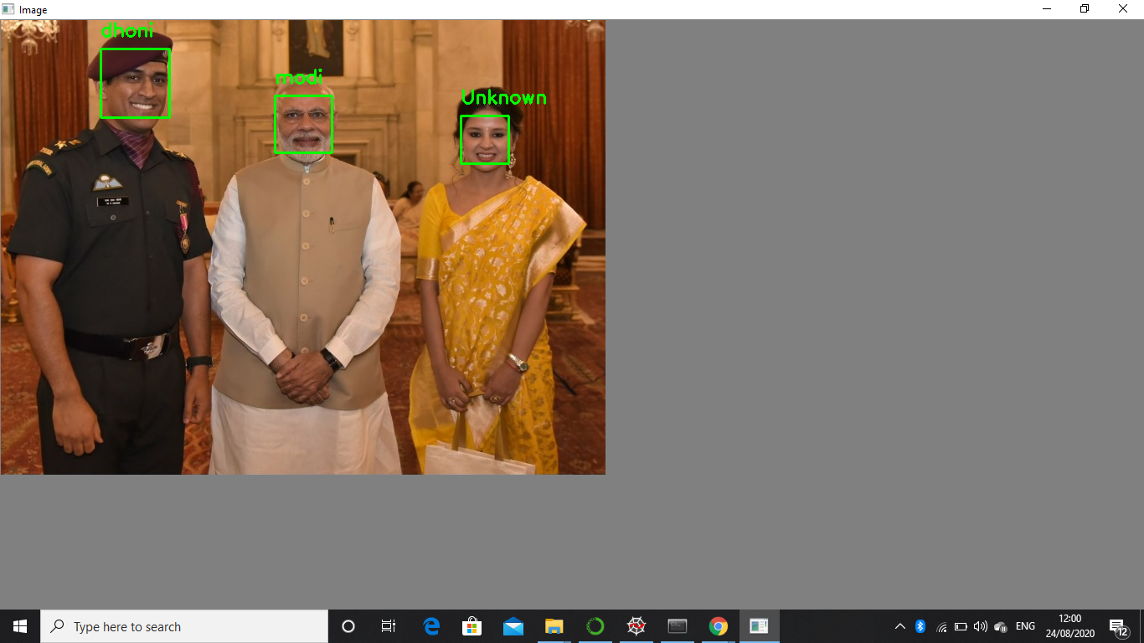

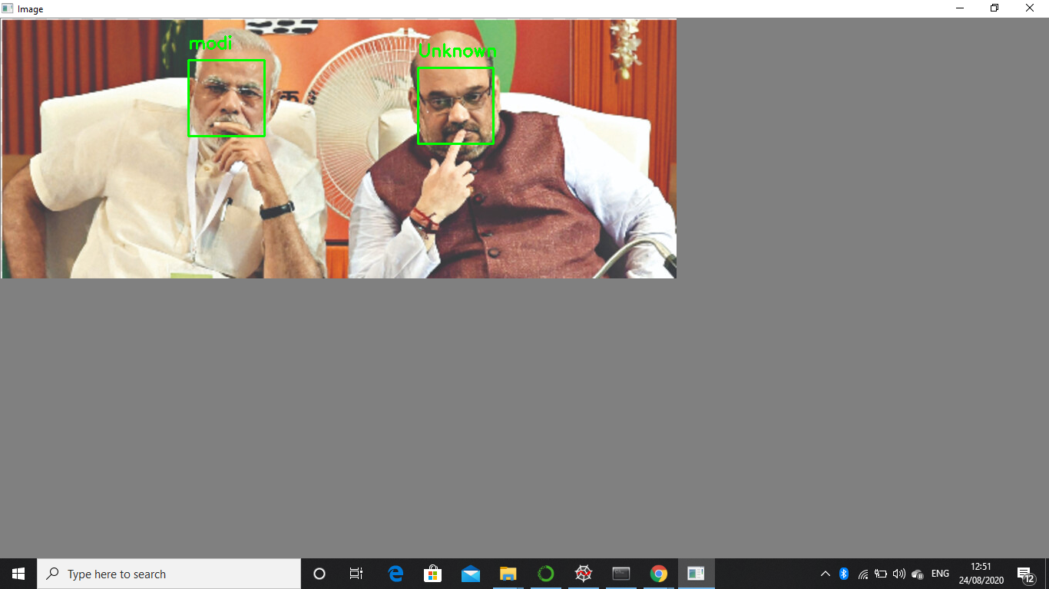

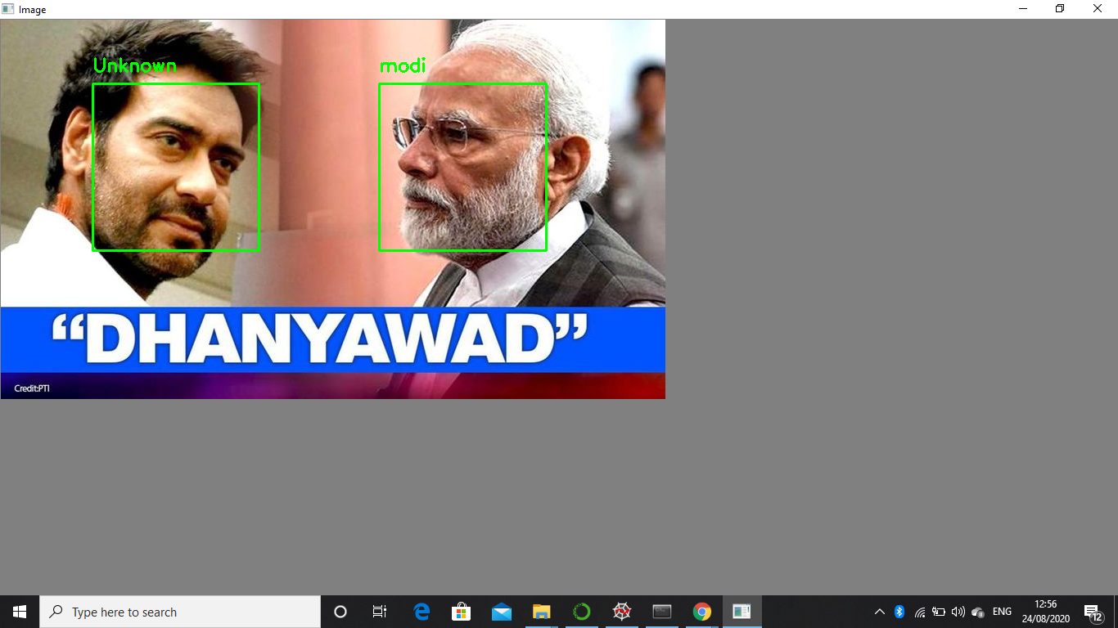



4. APPLICATIONS:-

While face recognition has been around in one form or another since the 1960s, recent technological developments have led to a wide proliferation of this technology. This technology is no longer seen as something out of science fiction movies like Minority Report. With the release of the iPhone X, millions of people now literally have face recognition technology in the palms of their hands, protecting their data and personal information. While mobile phone access control might be the most recognizable way face recognition is being used, it is being employed for a wide range of use cases including preventing crime, protecting events and making air travel more convenient.

We’ve compiled a list of 21 ways that face recognition is currently being used to make the world safer, smarter and more convenient.

## Prevent Retail Crime

Face recognition is currently being used to instantly identify when known shoplifters, organized retail criminals or people with a history of fraud enter retail establishments. Photographs of individuals can be matched against large databases of criminals so that loss prevention and retail security professionals can be instantly notified when a shopper enters a store that prevents a threat. Face recognition systems are already radically reducing retail crime . According to our data, face recognition reduces external shrink by 34% and, more importantly, reduces violent incidents in retail stores by up to 91%.

## Unlock Phones

A variety of phones including the latest iPhone are now using face recognition to unlock phones. This technology is a powerful way to protect personal data and ensure that, if a phone is stolen, sensitive data remains inaccessible by the perpetrator.

## Smarter Advertising

Face recognition has the ability to make advertising more targeted by making educated guesses at people’s age and gender. Companies like Tesco are already planning on installing screens at gas stations with face recognition built in. It’s only a matter of time before face-recognition becomes an omni-present advertising technology.

## Find Missing Persons

Face recognition can be used to find missing children and victims of human trafficking. As long as missing individuals are added to a database, law enforcement can become alerted as soon as they are recognized by face recognition—be it an airport, retail store or other public space. In fact, 3000 missing children were discovered in just four days using face recognition in India!

## Help the Blind

## Listerine has developed a groundbreaking facial recognition app that helps the blind using face recognition. The app recognizes when people are smiling and alerts the blind person with a vibration. This can help them better understand social situations.

## Protect Law Enforcement

Mobile face recognition apps, like the one offered by FaceFirst, are already helping police officers by helping them instantly identify individuals in the field from a safe distance. This can help by giving them contextual data that tells them who they are dealing with and whether they need to proceed with caution. As an example, if a police officer pulls over a wanted murderer at a routine traffic stop, the officer would instantly know that the suspect may be armed and dangerous, and could call for reinforcement.

## Aid Forensic Investigations

Facial recognition can aid forensic investigations by automatically recognizing individuals in security footage or other videos. Face recognition software can also be used to identify dead or unconscious individuals at crime scenes.

## Identify People on Social Media Platforms

Facebook uses face recognition technology to automatically recognize when Facebook members appear in photos. This makes it easier for people to find photos they are in and can suggest when particular people should be tagged in photos.

## Diagnose Diseases

Face recognition can be used to diagnose diseases that cause detectable changes in appearance. As an example, the National Human Genome Institute Research Institute, uses face recognition to detect a rare disease called DiGeorge syndrome, in which there is a portion of the 22nd chromosome missing. Face recognition has helped diagnose the disease in 96% of cases. As algorithms get even more sophisticated, face recognition will become an invaluable diagnostic tool for all sorts of conditions.

## Recognize VIPs at Sporting Events

Face recognition can be used to provide fans with a better experience. Face recognition can instantly recognize when season ticketholders attend sporting events. Event venues can offer them swag, let them skip lines and other VIP perks that result in greater season ticketholder retention.

## Protect Schools from Threats

Face recognition surveillance systems can instantly identify when expelled students, dangerous parents, drug dealers or other individuals that pose a threat to school safety enter school grounds. By alerting school security guards in real time, face recognition can reduce the risk of violent acts.

## Validate Identity at ATMs

It seems likely that face scans will eventually replace ATM cards completely since face recognition is such a powerful identity authentication tool. But in the meantime, face recognition can be used to make sure that individuals using ATMs cards are who they say they are. Face recognition is currently being used at ATMs in Macau to protect peoples’ identities.

Conclusion:-

**Face recognition technology** has come a long way in the last twenty years. Today, machines are able to automatically verify identity information for secure transactions, for surveillance and security tasks, and for access control to buildings etc.And I have successfully implemented that on my project recognizing and detecting the faces.The facial expression recognition system presented in this research work contributes a resilient face recognition model based on the mapping of behavioural characteristics with the physiological biometric characteristics. The physiological characteristics of the human face with relevance to various expressions such as happiness, sadness, fear, anger, surprise and disgust are associated with geometrical structures which restored as base matching template for the recognition system. The behavioural aspect of this system relates the attitude behind different expressions as property base. The property bases are alienated as exposed and hidden category in genetic algorithmic genes. The gene training set evaluates the expressional uniqueness of individual faces and provide a resilient expressional recognition model in the field of biometric security. The design of a novel asymmetric cryptosystem based on biometrics having features like hierarchical group security eliminates the use of passwords and smart cards as opposed to earlier cryptosystems. It requires a special hardware support like all other biometrics system. This research work promises a new direction of research in the field of asymmetric biometric cryptosystems which is highly desirable in order to get rid of passwords and smart cards completely. Experimental analysis and study show that the hierarchical security structures are effective in geometric shape identification for physiological traits.

6. FUTURE SCOPE:-

The use of spherical canonical images allows us to perform matching in the spherical harmonic transform domain, which does not require preliminary alignment of the images. The errors introduced by embedding into an expressional space with some predefined geometry are avoided. In this facial expression recognition setup, end-to-end processing comprises the face surface acquisition and reconstruction, smoothening, sub sampling to approximately 2500 points. Facial surface cropping measurement of large positions of distances between all the points using a parallelized parametric version is utilized. The general experimental evaluation of the face expressional system guarantees better face recognition rates. Having examined techniques to cope with expression variation, in future it may be investigated in more depth about the face classification problem and optimal fusion of color and depth information. Further study can be laid down in the direction of allele of gene matching to the geometric factors of the facial expressions. The genetic property evolution framework for facial expressional system can be studied to suit the requirement of different security models such as criminal detection, governmental confidential security breaches etc.

## 

## 

## 